IMPORTANT – before you start doing your solution, MUST do the following steps:

- Create your MS SQL database named JobDB by running code in script
JobDB.sql.
- Copy given file DBContext.java (2) to source package (src\java) folder under your web project. You might need to use and name a java package for (2), free to set the name of package.
- You MUST use DBContext.java for your all database connection.
- Set the home page/default for your project as AddJob.jsp page.

Questions:

Create a AddJob.jsp page with GUI as below figures (0.25 Point):
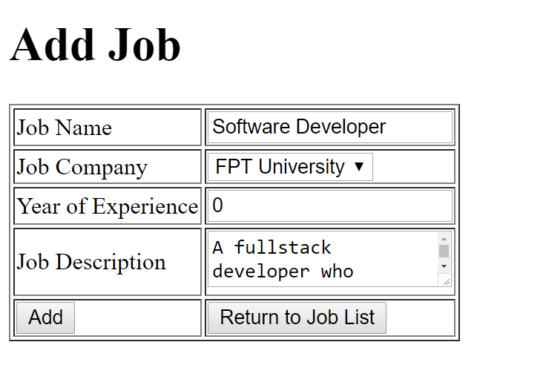

Requirements:
- Value for Year of Experience must be numerical (0.25 Point)
When the users click on Add button, validate the data on the input form as rules:
- Require data for all text fields (0.75 Point - 0.25 Point for each error message).
When the validation is correct.

Add information on input form to Job table (0.25 Point) and browse to ListJob.jsp page (0.25 Point).
When users click on the “Return To Job List” button, browse to ListJob.jsp page (0.25 Point) which will be shown as below.
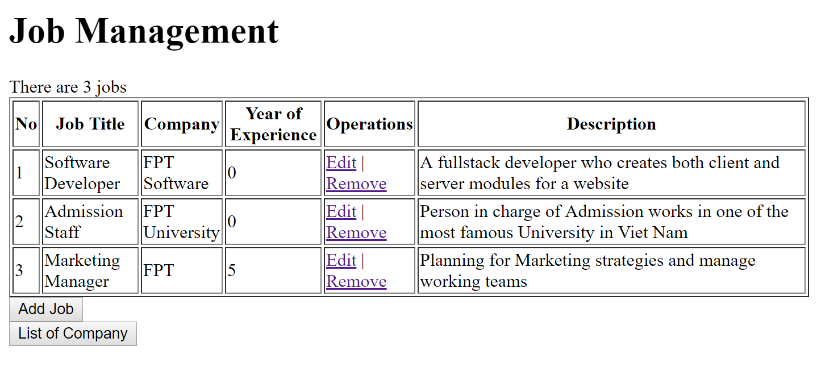
The table must have the same columns with one in above figures.
Requirements:
- Output all Jobs in Job table to ListJob.jsp as above table (0.5 Point).
- Calculate and display the number of Jobs of result (0.25 Point).
- Values for Company should be corresponding to the Company Name in Database (0.25 Point).
When users click on button “List of Company”, browse to ListCompany.jsp which will output information of all companies (0.5 Point),
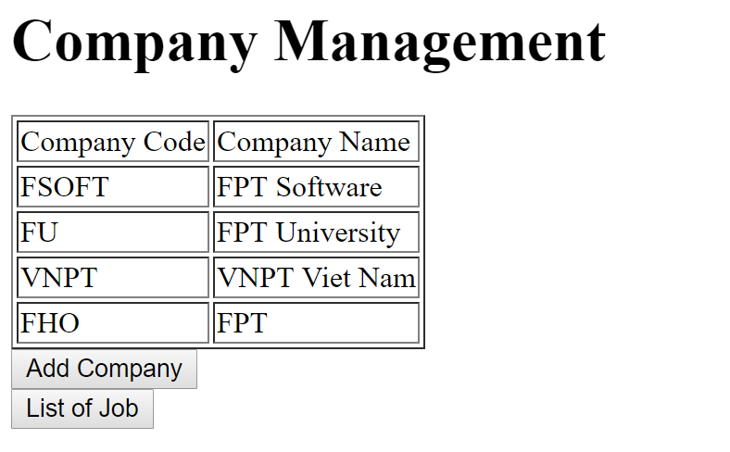

When users click on List Of Job, browse to ListJob.jsp page (0.25 Point).
When users click on Add Company, browse to AddCompany.jsp which will be used to add a new company into the database (0.25 Point)
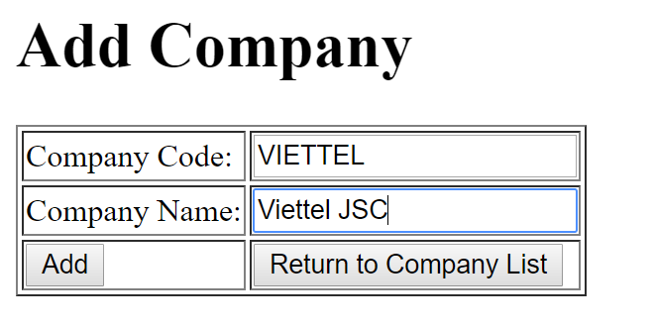
Requirements:
- Add information on input form to Company table (0.5 Point) and browse to ListCompany.jsp page (0.25 Point).
- When users click on the “Return To Company List” button, browse to ListCompany.jsp page (0.25 Point) which will be shown as below.

On the “Job List” page, when the users click on the link Remove, the corresponding record will be removed from the database, and the list will be refreshed to reflect the result. (0.25 Point)
When users click on the link Edit, browse to EditJob.jsp page (0.25 Point)
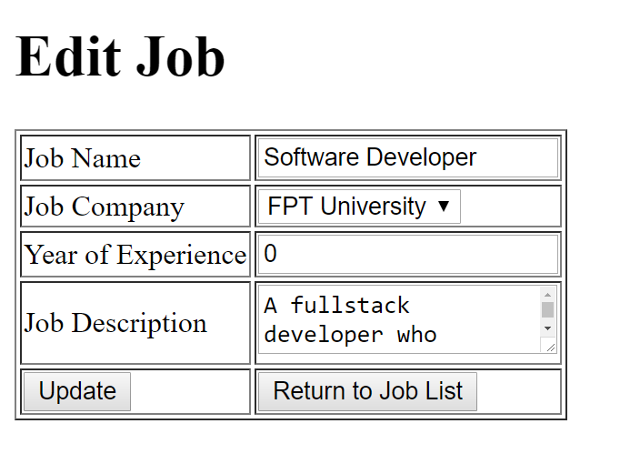
Requirements:
- Value for Year of Experience must be numerical (0.25 Point)
- When user click on “Update” button, save the edited information into the database (0.5 Point)
- When user click on “Return To Job List”, browse ListJob.jsp page. (0.25 Point)

